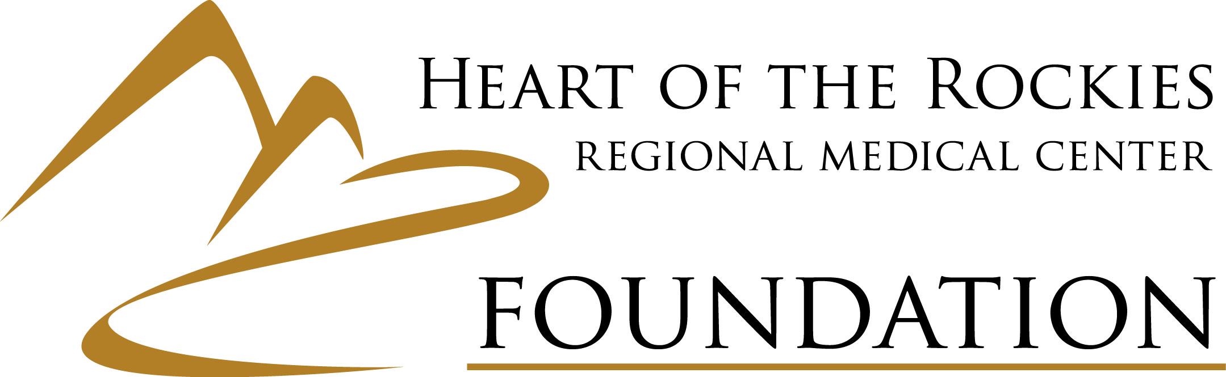
2019 Certified EMS to RN Scholarship
- Eligibility
- Any certified EMS (emergency medical technician/paramedic) who lives within the Salida Hospital District or Saguache County.
- Will be attending college fall or spring of 2019/2020 and pursuing an Associate Degree in Nursing.

- Review Process
- Scholarship Selection Committee will be assembled to review submitted applications (this usually occurs within three weeks of the application deadline).
- Applications will be reviewed by the HRRMC Foundation Scholarship Selection Committee.
- Each application will be scored on pre-established criteria.
- Scholarship Selection Committee will make a final award decision based on total scores of each application.
- Two annual scholarships for $5,000 will be awarded. Applicants and recipients must reapply each year.

- Application Components (scoring criteria)
- Completed one-page application form.
- A one-page narrative outlining why the applicant desires to receive the scholarship award and reason of wanting to become an RN.
- Two (2) letters of reference. One professional reference (academic or work related) and one personal reference (friend or community member).
- Acceptance Letter to college/program.
- Copy of current EMS License/Certification. Applicants should provide their professional license number.

- Application Deadline
- Applications must be postmarked on or before July 12, 2019.

- Notification & Payout
- Following approval, HRRMC Foundation will notify all applicants of award decision(s).
- Scholarship award will be paid directly to the institution where applicant has been accepted in two equal installments (First and Second Semester).
- Second Semester installment will be sent after the HRRMC Foundation receives copy of First Semester Transcript.
- Scholarship earmarked for Tuition/Books/Room and Board only.
- Submission of Application
- Applications should be sent to:
HRRMC Foundation
Scholarship Selection Committee
P.O. Box 429
Salida, CO 81201

Direct inquiries to 719.530.2218

