 |  | Oncology Rehabilitation Screening  Please fill this form out for an oncology physical therapist to review.  Look over the brochure to learn about oncology rehab services available at HRRMC.  Contact Lisa at 719-530-2392 for more information
CHECK ALL THAT APPLY:

 | Difficulty completing daily activities such as: getting dressed, bathing |  |  |  | Increase effort required to get up/down from chairs or toilet.
 | Feel limited in your ability to walk prolonged distances in the community, such as shopping or doctors’ appointments |  |  |  | Difficulty completing activity around your house, such as: carrying groceries, lifting a gallon of milk, doing laundry, preparing meals
 | Had a fall or near fall in the past 3 months, or feel the need to reach for furniture or walls for stability |  |  |  | Pain with intimacy. Pain or numbness in your genitals with intimacy and/or intercourse.
 | Noticed a decline in your balance. Feel unsteady on your feet. |  |  |  | Difficulty with urination and/or defecation
 | Changes to voice or difficulty swallowing. |  |  |  | New onset of dizziness or vertigo
 | Numbness/tingling, heaviness, or swelling in the extremities that affects your daily function or fine motor skills |  |  |  | Experience tightness, pain, or decreased motion around an area of surgical or radiation treatment.
PHYSICAL ACTIVITY
Being physical active can be challenging after a cancer diagnosis. Research clearly shows that most people who are more active during cancer treatment have fewer side effects, faster recovery from treatment, and less risk of cancer returning.

American Cancer Society guidelines: Get 150-300 minutes of moderate intensity or 75-150 minutes of vigorous intensity activity each week (or a combination of these).

If you are not achieving these guidelines, the recommendation is to start slowly building up. Physical therapists or exercise physiologists can help you to do this safely and effectively before, during, or after your cancer treatments.

I am currently meeting the guidelines.
(example: about 30 minutes of moderate intensity activity 5 days per week)
I was meeting the guidelines, but recently have not been able to stay as active.
I am not meeting the physical activity guidelines.

FATIGUE
Consider the past several weeks.  Using this scale, please rate your: | Current Fatigue Level: _________  Worst Fatigue Level: __________ | 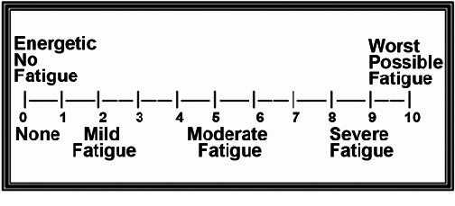

Any other concerns that you’d like to speak to an oncology physical therapist about:

Phone number where an oncology physical therapist can reach you to discuss recommendations:

For therapist use only

